ALR Renewal process in Tamam platform

**Step 1**:- Login to school’s coordinator’s account

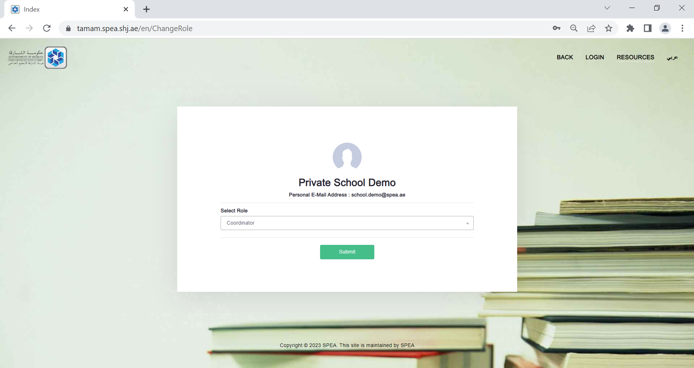

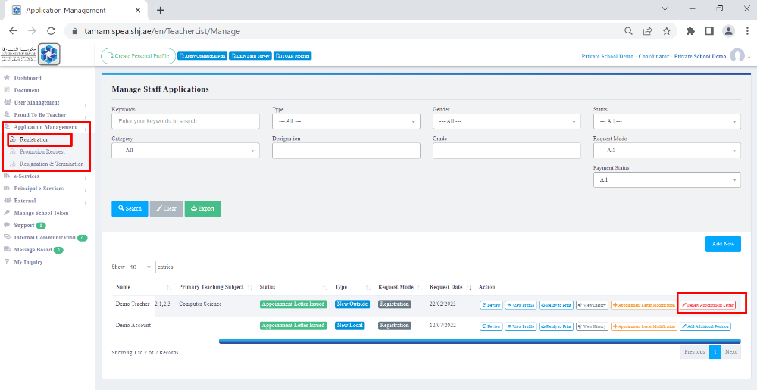**Step 2:**-

Click on:

1. “Application Management”.
2. Choose “Registration.
3. The list of all needed renew employees will be shown.
4. Shape, arrow

   Description automatically generatedScroll to right and click on “Renew Appointment Letter”.

**Step 3**:- Type “Renew” and click on “Confirm”

**Step 4**:- Click on “Edit Profile” to attach new requested information

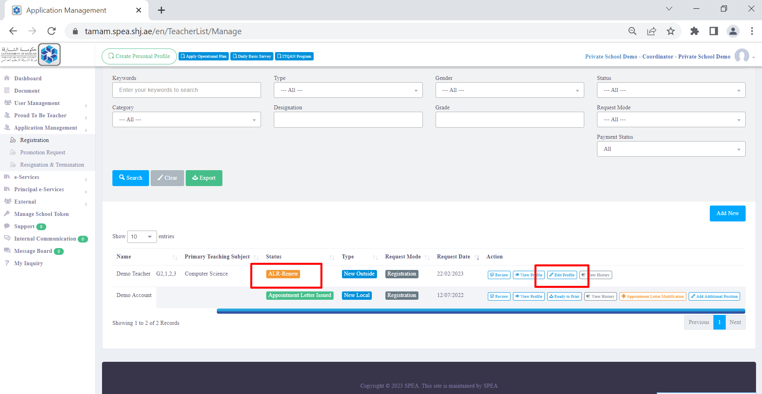

**Step 5**:- Go to “Professional Development” and click on “Add”.

**Step 6**:- Please fill the requested information regarding the professional development and attach the certificate.

**Step 7:-** Go to “Documents”

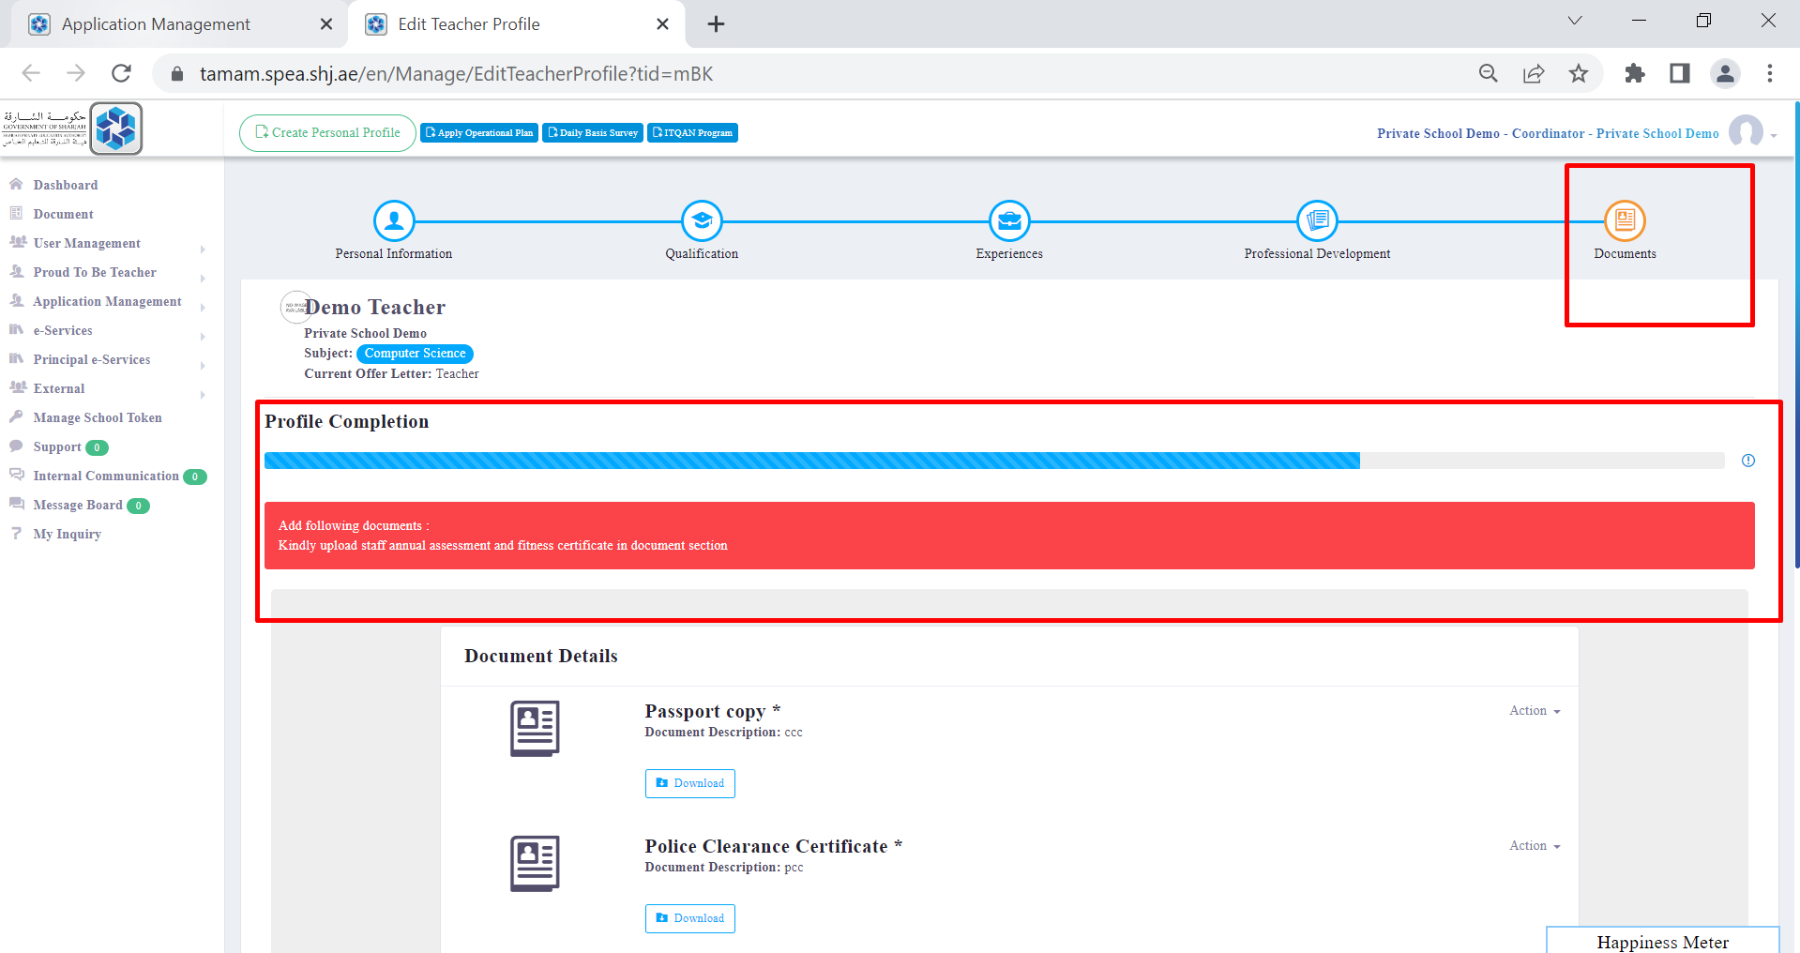

**Step 8:-** Click on “Add” which will be found down on the right.

**Step 9:-** Please attach school’s annual report regarding the candidates performance that is done yearly for staff members and click on “Save”

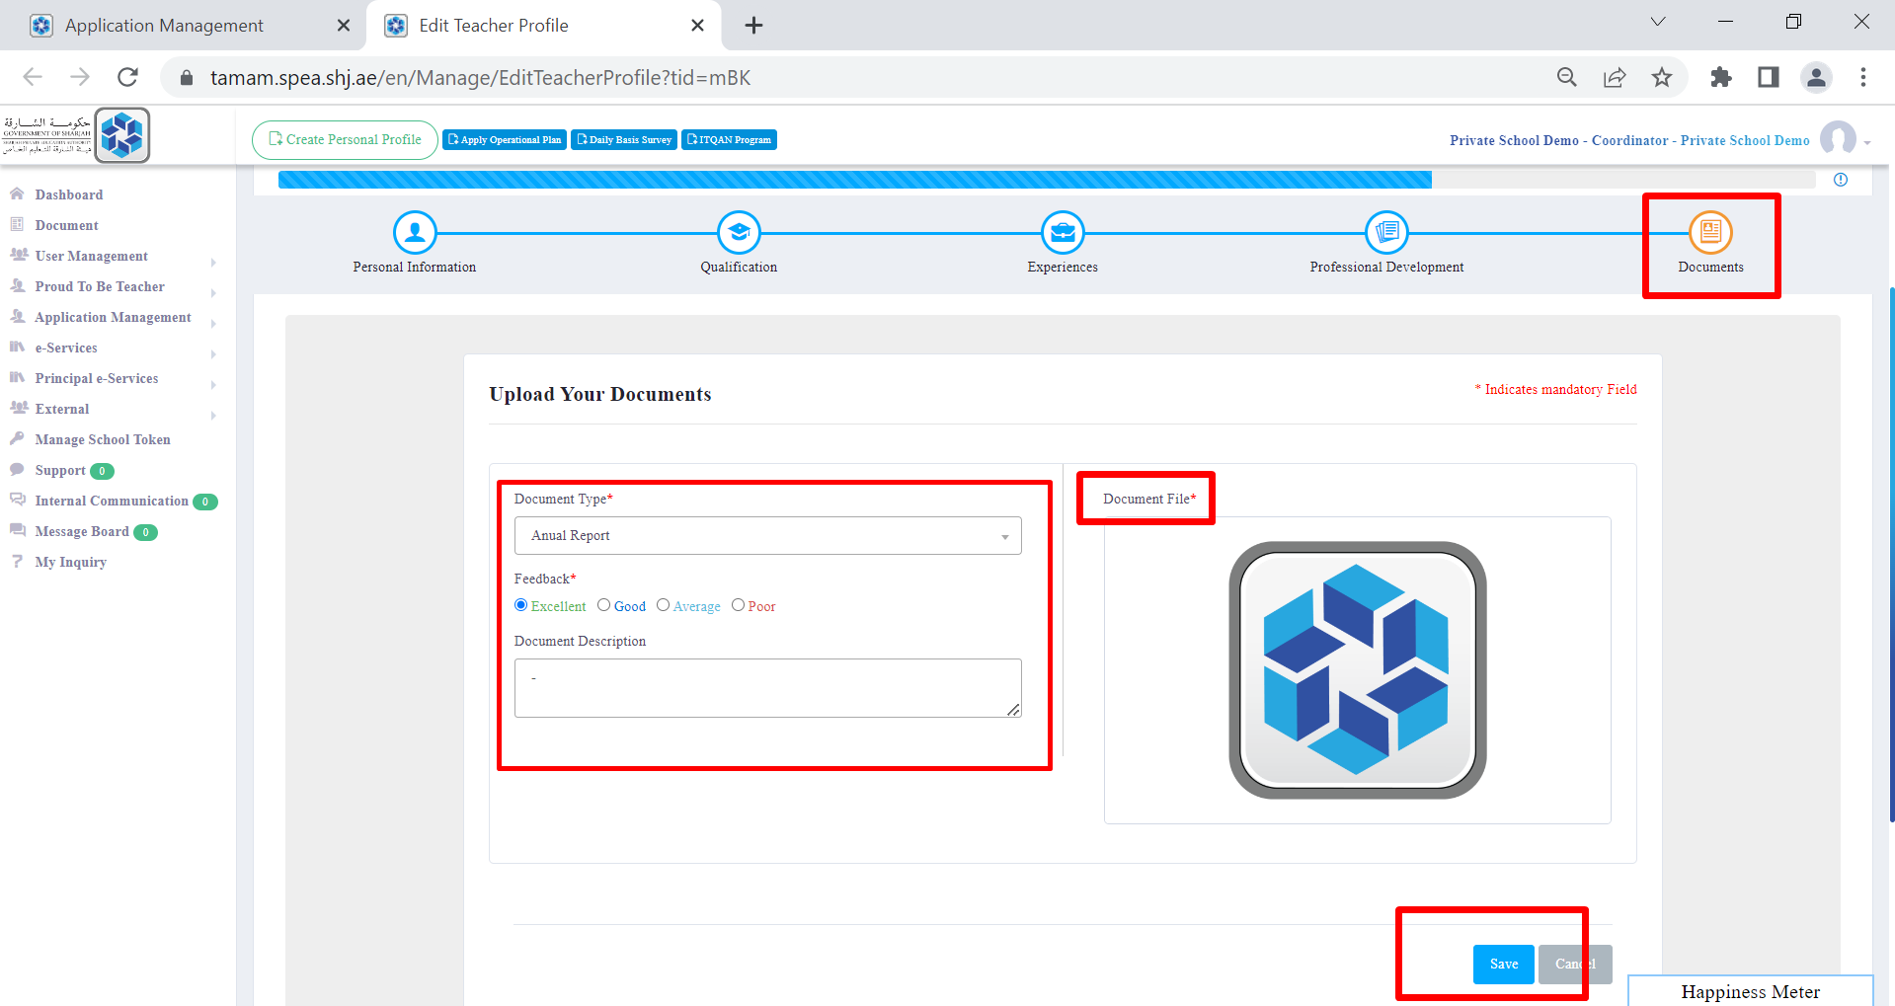

**Step 10:-** Repeat step 8

**Step 11:-** Please attach fitness certificate and click on “Save”

**Step 12:-** Please click on “Submit For Review” to be sent to SPEA for renewal

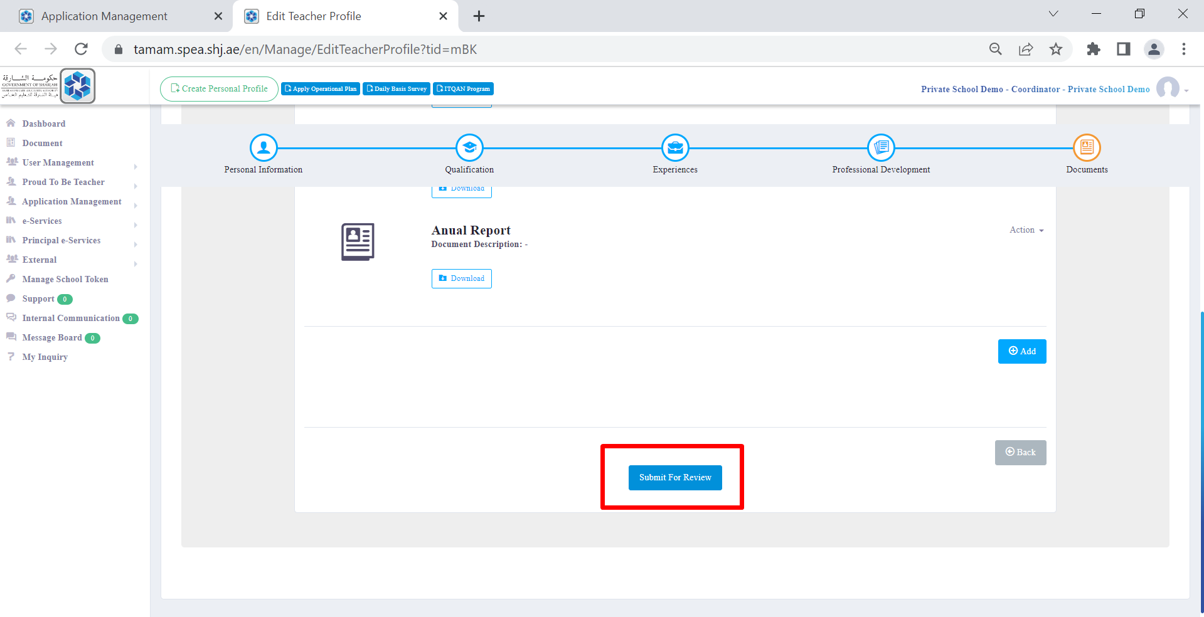

**Step13:-** status will be changed ALR Pending SPEA Approval

